
DEPARTMENT OF CSE
A.Y. 2026 – 2027
B.Tech. III Year Odd Semester

COURSE: CNAD (24CND3101)
PROJECT ABSTRACT SUBMISSION
TITLE OF THE PROJECT | Cloud-Based Food Surplus Prediction and Hyperlocal Redistribution Network
S. No. | University ID | Name
1 | 2420030073 | Y. Bhavika
2 | 2420030038 | N. Keerthi Sri
3 | 2420030149 | Y. Adarsh Rishi
Name of the Guide |  | P. Srilatha

Abstract
Food surplus is generated every day by restaurants, supermarkets, hotels, cafeterias, events, and households, while many communities continue to face food insecurity. A major challenge is that surplus food is often identified too late, is difficult to match with nearby beneficiaries, or becomes unusable before redistribution. This project proposes a cloud-based platform that predicts food surplus and coordinates its hyperlocal redistribution so that usable food can reach nearby people and organizations in a timely manner. The proposed system collects relevant historical and real-time information such as food type, quantity, preparation or expiry time, demand patterns, day of the week, location, and previous surplus records. A machine-learning based prediction module estimates the expected quantity and timing of surplus. The cloud platform then uses these predictions to create alerts and match available food with nearby verified receivers such as NGOs, community kitchens, shelters, and food banks. The redistribution layer focuses on hyperlocal matching by considering geographic proximity, food type, quantity, urgency, receiver capacity, and pickup availability. A service-oriented architecture can separate major functions such as user management, surplus registration, prediction, matching, notifications, and tracking into manageable services.
Keywords: Food Surplus Prediction, Food Waste Reduction, Hyperlocal Redistribution, Machine Learning, Cloud Computing, Microservices, Location-Based Matching

Signature of the Guide Signature of the Course Coordinator HOD
Tools and Technologies Used for the Project:
Category | Tools / Technologies
Front-End | React / HTML / CSS
Back-End | Node.js / Express / Spring Boot
Database | MySQL / PostgreSQL / MongoDB
REST API | Service Communication
Deployment | Render (Free Tier)
Maps & Locations | Leaflet + OpenStreetMap

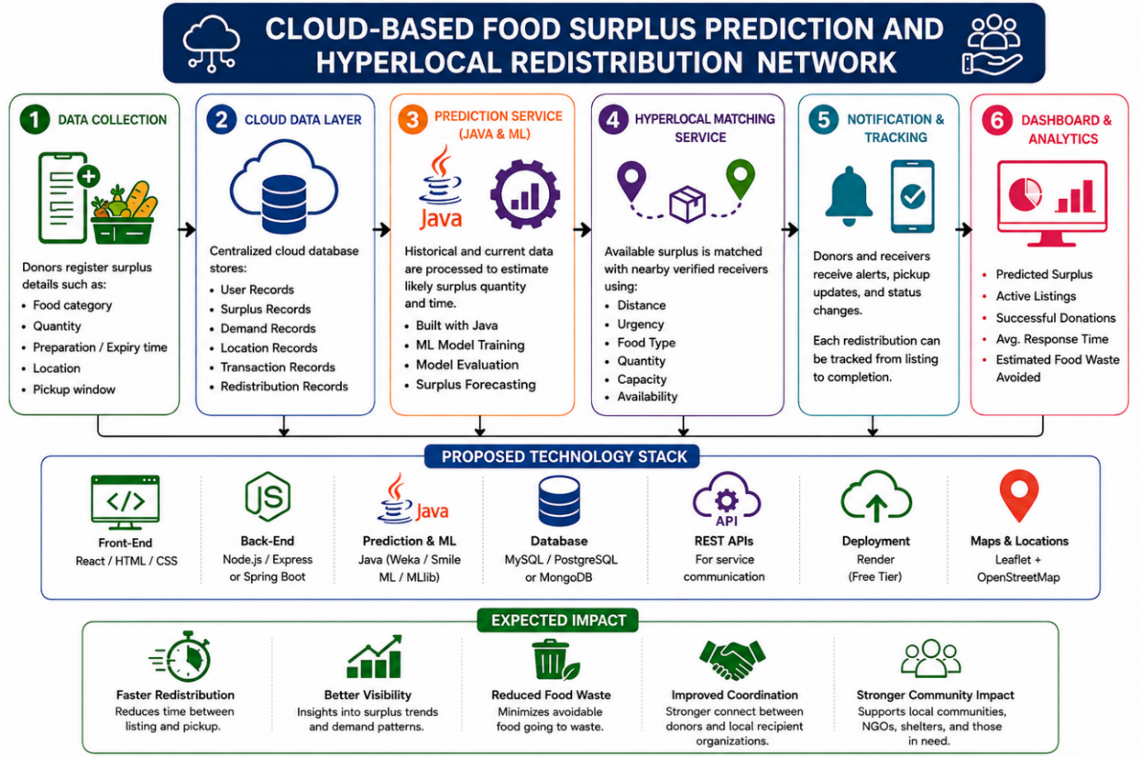

Signature of the Guide Course Coordinator HOD

